How to Use gitHub codespaces

This document will help you navigate yourself through your first program using gitHub classrooms.
Good luck and don’t panic. If you are stuck, I can come around and help you.
- Click on the assignment link in canvas
- Click on Accept this assignment
- Click on the blue highlighted address
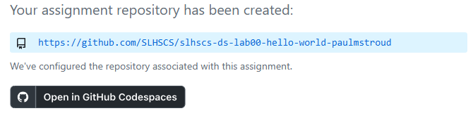
- This will give you access to all the files
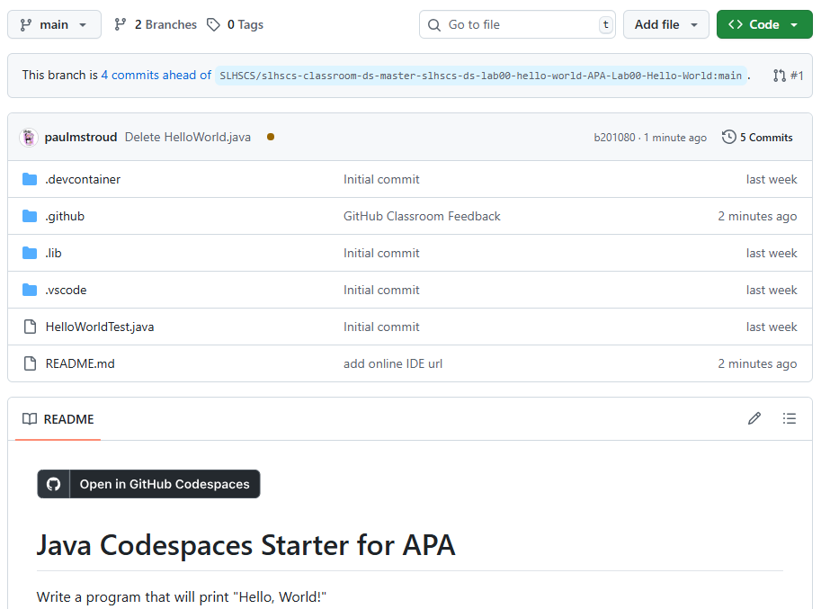
- Please do not mess with .devcontainer, .github, .lib, .vscode, the readme, nor any files that have Text in the title for they help with the autograding.
- Read the readme file to see what the assignment entails. In this case printing Hello, World!
- Click on Open in GitHub Codespaces, and you will get the following page:
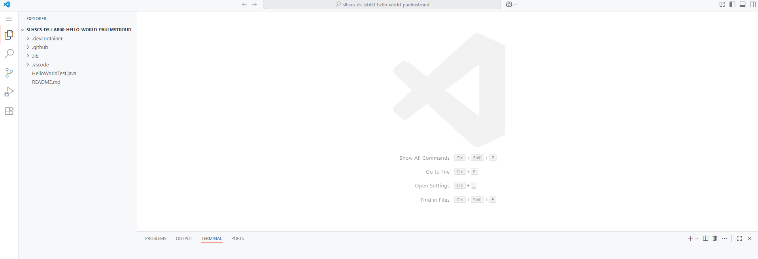
- Notice that the readme is in here as well.
- Under explorer, you can add a file clicking the document+ button and call it the appropriate name, in this case HelloWorld.java
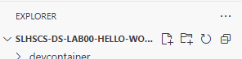
- Here is the result
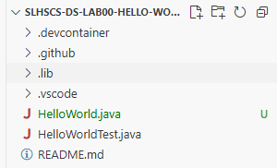
- Now just write the code in the HelloWorld.java space
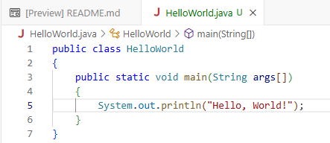
- We need to click on the arrow in the upper right corner to run the code to see if it works, as seen in the image below
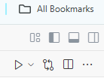
- The first time you do this, you may get prompted to run on standard java, you can say yes. Now the terminal will produce a bunch of stuff because it is running on prompt.
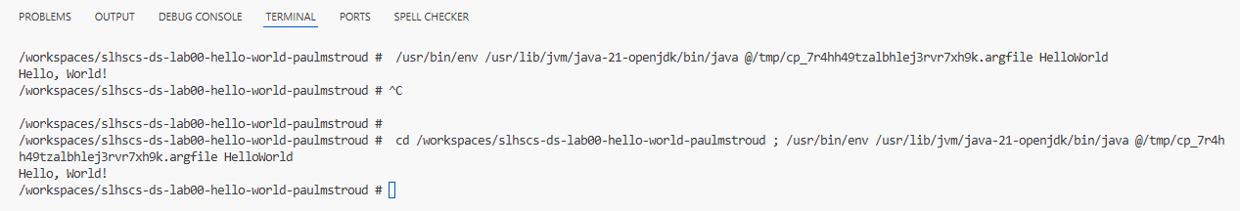
- However, what you care about is this section here
- Congratulations, you have successfully run your first program. Now we need to upload it for grading. This is called committing. Clicking on the the following icon will bring up the commit button
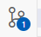
- Above the Commit button is a message which you fill in with some note to yourself, like HelloWorld commit 1, then push the arrow down on commit and choose Commit & Sync
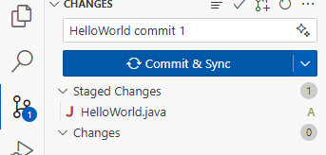
- You have now committed your code to grade. As the year goes on, you will start to see that you won’t get the full credit, but that’s okay, you can always fix your code and recommit.
- You will be able to see feedback in classroom, which will say if you got it right. Here is an example of a wrong submission
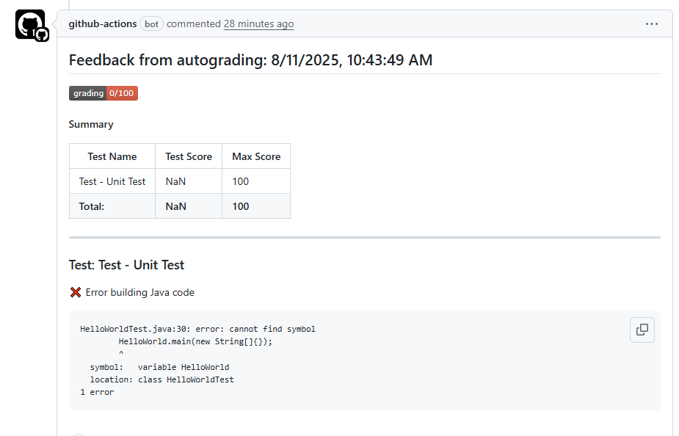
- Here is an example of a right submission
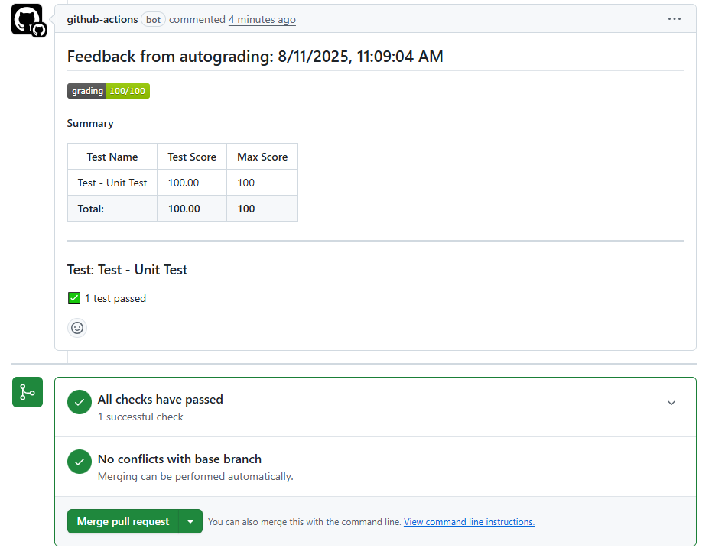

CONGRATULATIONS! You have passed a Rite of Passage! Every programmer in the world writes Hello, World! as one of their first programs. Tell your parents, chances are they have programmed in the past and this was their first program. Enjoy the moment, it is cool, and your parents will probably get a kick out of it.

